Challenge-4 on VPC Endpoint and Transit Gateway
Use Case: Setting up Transit Gateway and VPC Endpoints for a Multi-VPC Architecture
Scenario:
A large organization is migrating its on-premises infrastructure to the AWS cloud.
The organization's architecture involves multiple VPCs for different departments and applications, each requiring secure communication with centralized services and external resources.
The IT team needs to design and implement a scalable and efficient network architecture to accommodate the organization's growth and ensure robust connectivity between VPCs and external services.
Objectives:
- Design and deploy a scalable network architecture using AWS Transit Gateway to simplify network connectivity between multiple VPCs.
Step by step implementation
- Create 4 VPC’s
- Create 4 subnets (1 public and 3 private) and configure with 4 VPC’s
- Create an internet gateway and attach to a VPC which has public subnet
- Create a transit gateway.
- Now add transit gateway attachments for 4 VPC’s
- Create route tables for each VPC’s
- Launch 4 instances with the VPC and subnets.
- Connect to the public ip (on-premises instance) using ssh -i keys.pem ec2-user@<public IP>
- Connect with all private IP’s of dev, prod and staging instances using on-premises instance ssh connection as jump server.
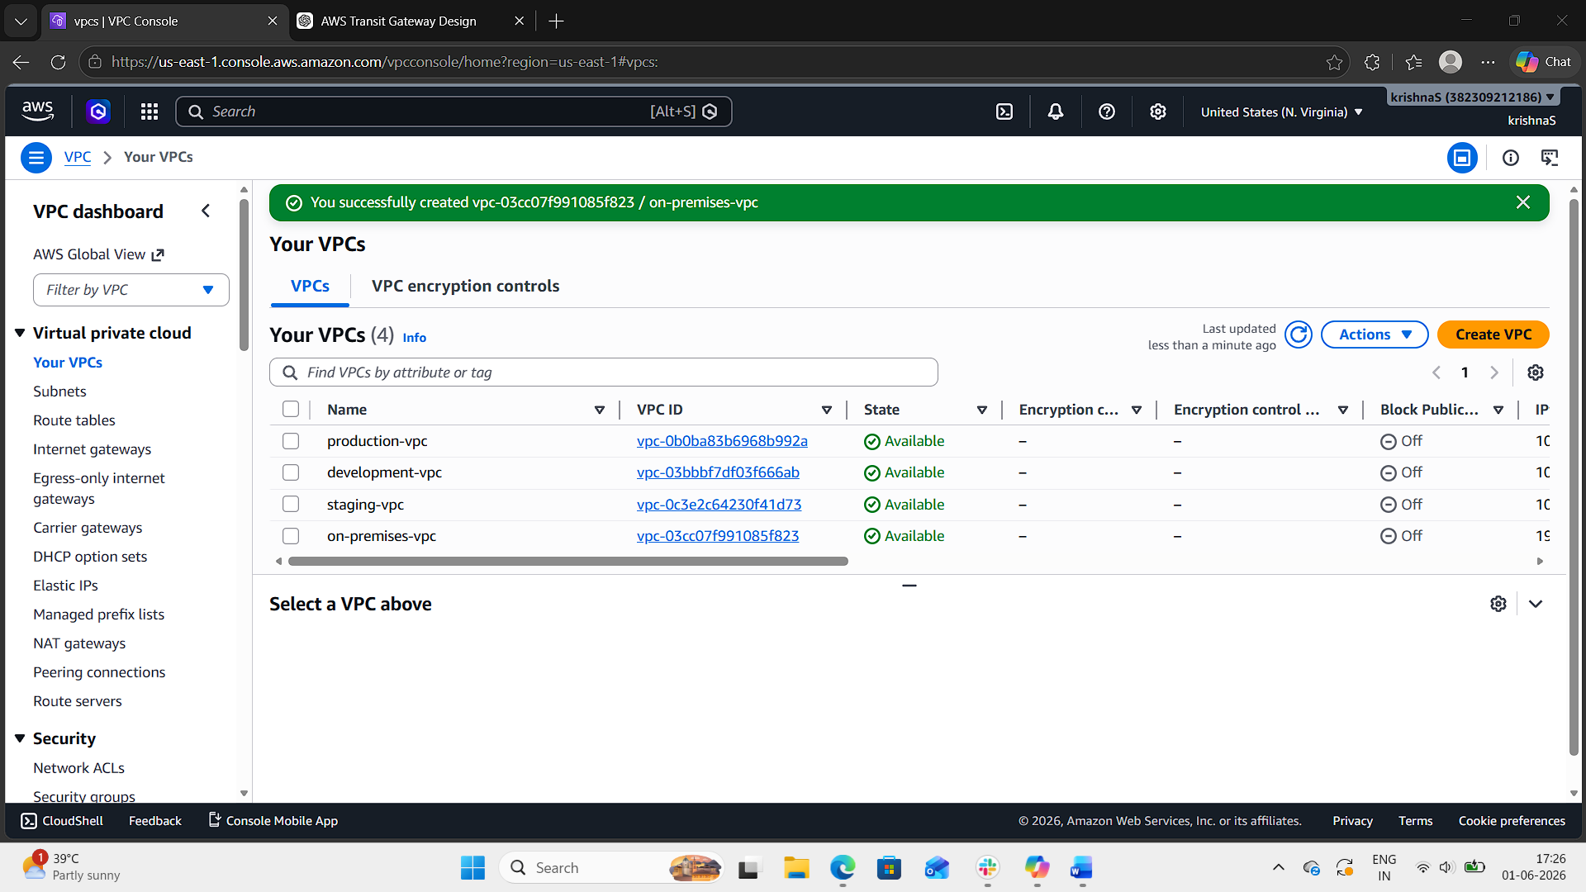
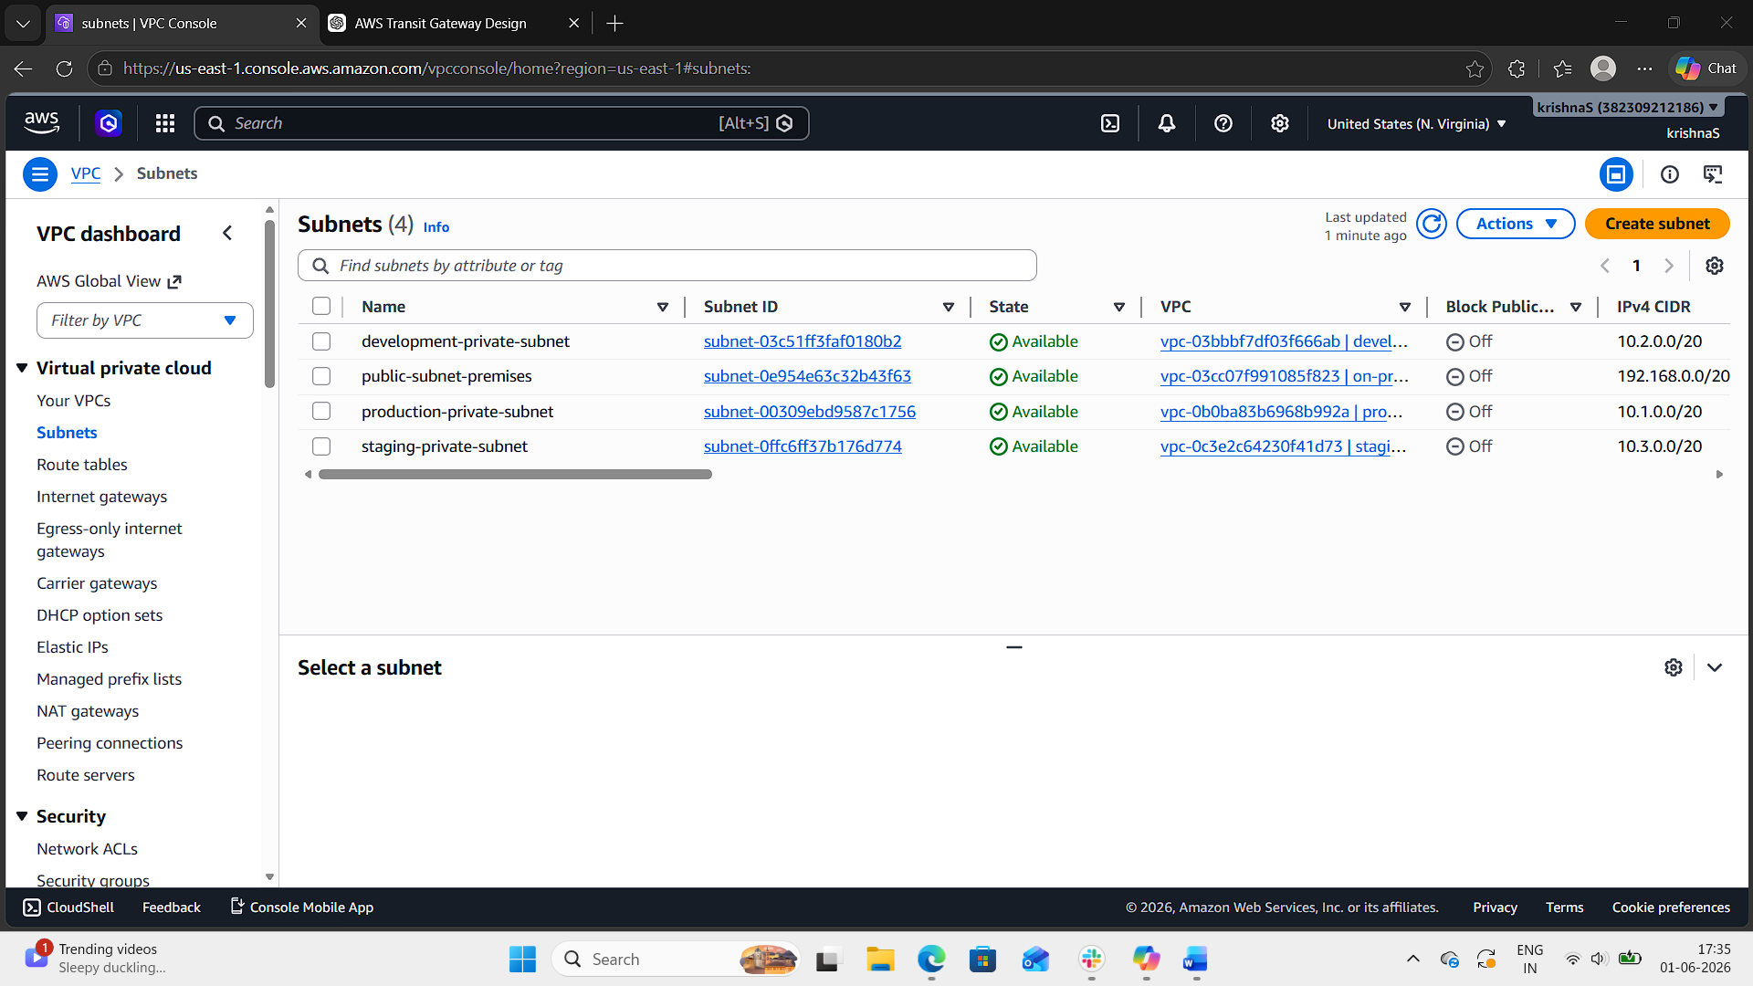
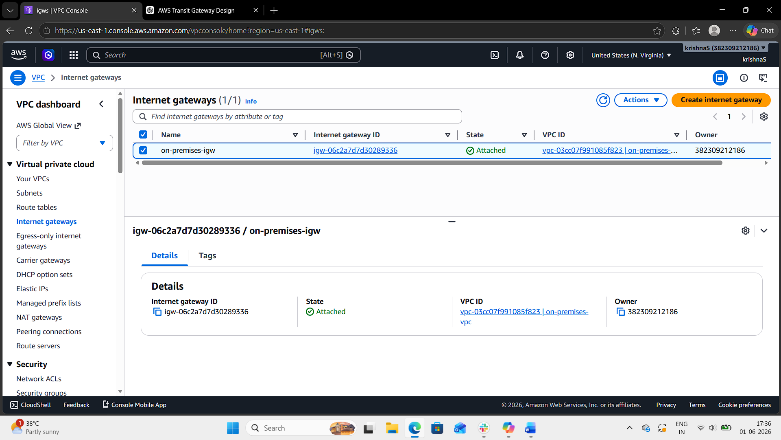
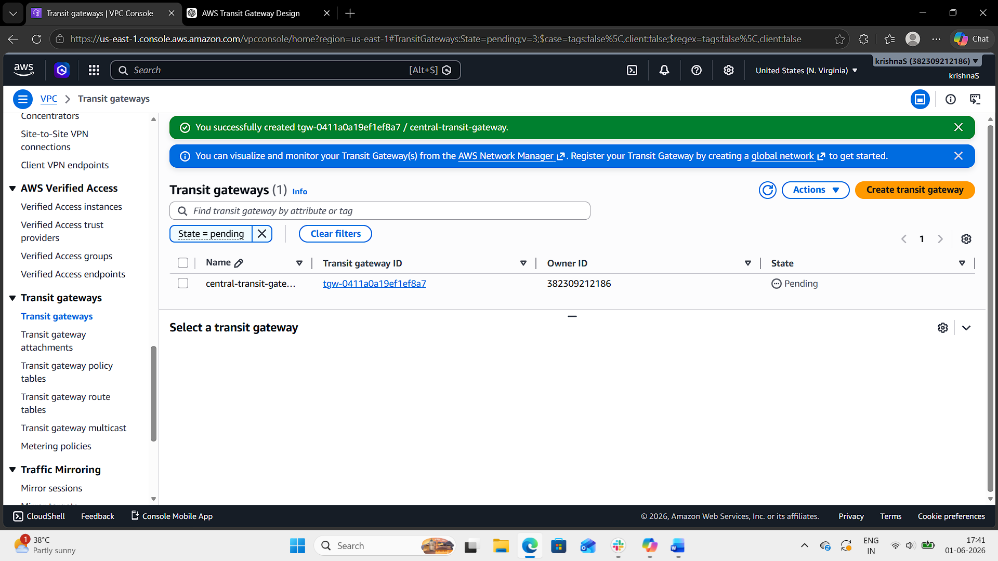
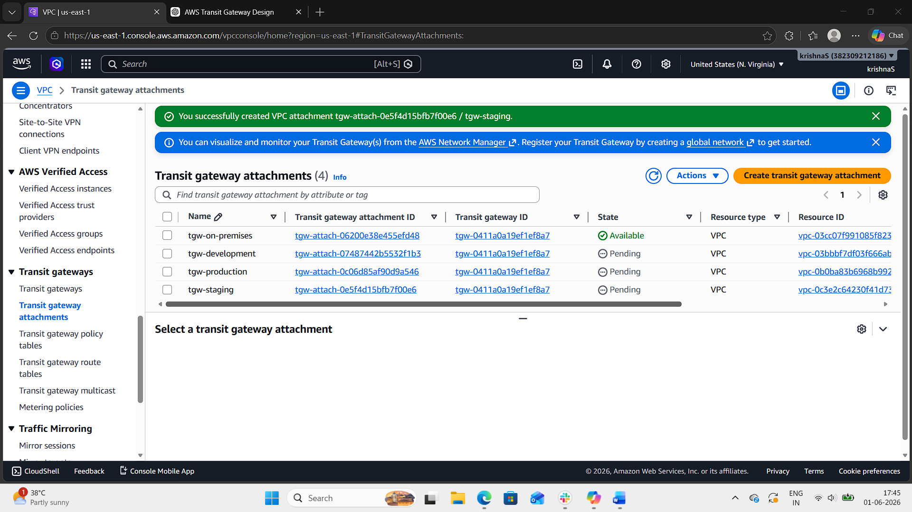
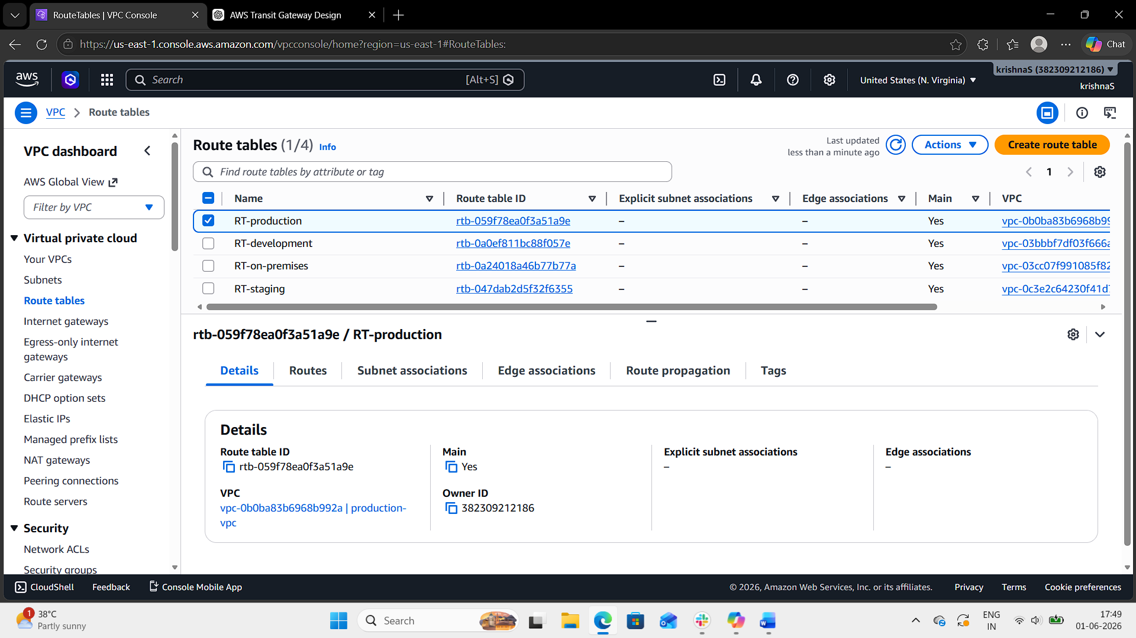
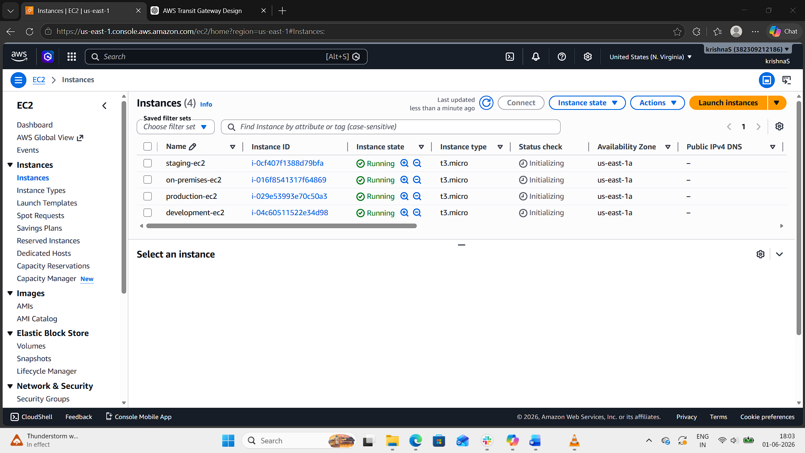
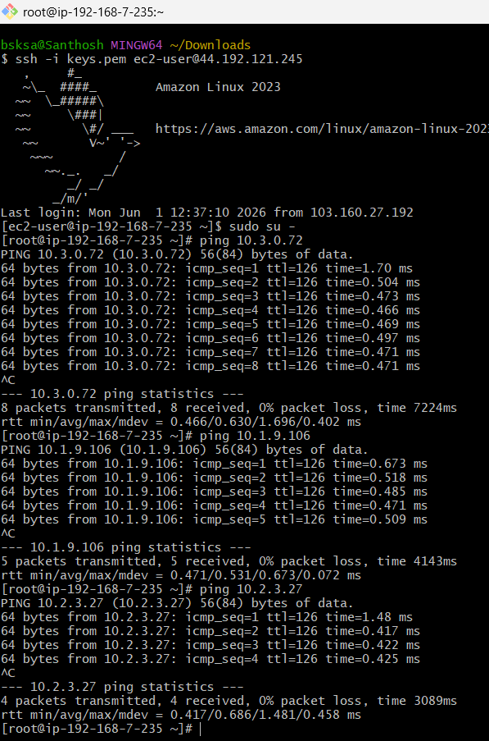

- Configure VPC endpoints to securely access AWS services without internet gateways or NAT gateways, ensuring data privacy and minimizing exposure to external threats.
Step by step implementation:
- Create 1 VPC with 1 public and 1 private subnet.
- Create 1 S3 bucket.
- Launch 1 instance in public and 1 instance in private subnet.
- Try to use public EC2 as bastion and connect to private and execute “aws s3 ls” this command will not work because of no internet access.
- Now go to VPC end point service.
- Create an end point, search for s3 and use s3 endpoint category “aws services”
- End point url “com.amazonaws.us-east-1.s3” type “gateway” select private route table.
- Now try to access s3 with private EC2 and this will work.
